Note that the Agent is not liable per IRS Form 2678 until the IRS has authorized such in writing. IRS authorization usually occurs within 60 days of submitting this form. Programs should ensure that their administrative contract or provider agreement with the agent stipulates that the agent will withhold, deposit and file participant employer federal taxes even before the IRS has authorized such in writing.
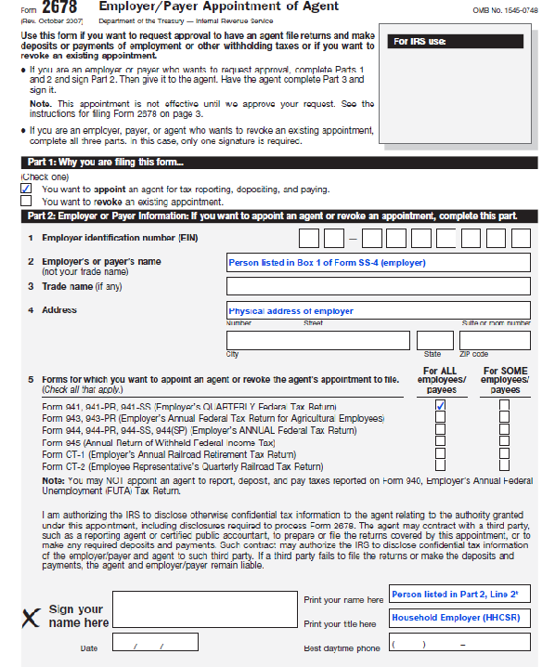
This form is first used to appoint an agent. If the participant quits the program or transfers to a different F/EA, the existing agent should be revoked. Check box as appropriate.
Enter the EIN for the participant that was obtained with Form SS-4.
The participant or representative employer appoints an agent. Individual named here should match individual in Box 1 of Form SS-4.
Individual listed in part 2, Box 2 should sign, date and print name here. An exception is if a guardian for the individual listed in Part 2, Line 2 has been court appointed. If a guardian for the person has been court appointed, guardian should sign, date and attach copy of court appointed guardianship papers with court seal visible.
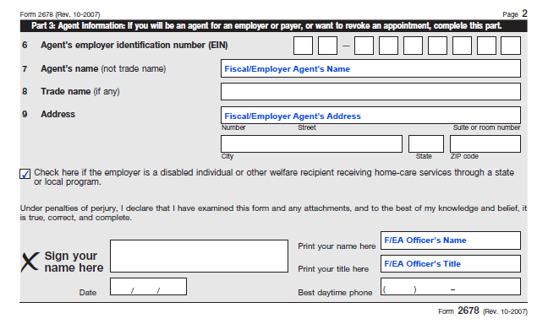
Complete with Fiscal/Employer Agent’s Separate EIN. This EIN should only be used for serving as a Fiscal/Employer Agent and not for depositing employment taxes or filing returns for the Agent’s own staff.
Only an individual with binding signatory authority for the Fiscal/Employer Agent should sign this form. Individual should sign, date, print name, title and best daytime phone number.

